Camp Joy’s Winter Tree Dichotomous Key

1a. Branches, twigs and leaf scars are opposite…. 2

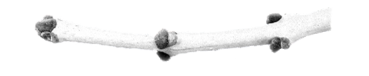

1b. Branches, twigs and leaf scars are alternate…. 7

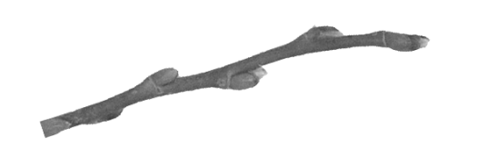

2a. Buds are almond size, thick and scaly ….***Ohio Buckeye***

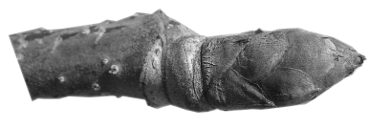

2b. Buds are not as large….3

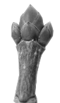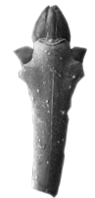  
3a. Plants with green or greenish/purple twigs…. 4

3b. Plants with twigs other than green…. 5

4a. Green twigs with short buds, with few scales, a shade of pink at the base with a white tip; Bark has a slight orange color to it.  Has paired samara…. ***Box Elder***

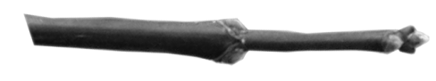

4b. Twigs have one side that’s flat with the other side sometimes purplish; leaf buds are 2 scaled and paintbrush shape, flower buds have a white onion shape with 4 scales; twigs are largest where the buds come out and get skinnier; as the tree gets older the bark gets a more scale like pattern. Often has a red fruit…. ***Flowering Dogwood***

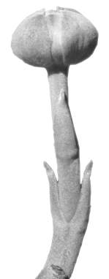

5a. End or top of buds have 2-4 scales, folded together to be triangle or star shaped, side buds singular; fruit, if present, is paddle-shaped samaras…. ***White Ash***

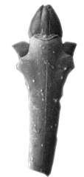

5b. End buds have many scales, are paint brush or round in shape, side buds singular; fruit, if present, a double winged samara….6

6a. Buds and twigs have a red to reddish-black color; buds are round and lightly scaled…. ***Red Maple***

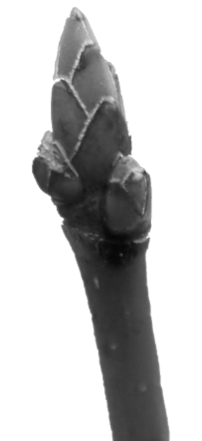

6b. Buds and twigs not red, buds are fat paint brush shaped, have many scales…. ***Sugar Maple***



7a. Plants with thorns……..8

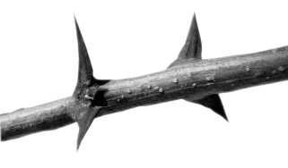

7b. Plants without thorns….. 10

8a.   Plants with paired thorns; buds small, brownish and located between thorns; fruit, a 3 inch pod…..***Black Locust***

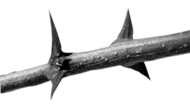

8b. Plants with single or alternating thorns; plant grows upright; round twigs…..9

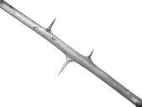

9a. Plants with many thorns, flaky bark, and long flat fruit pods….. ***Honey Locust***

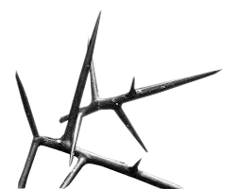

9b.   Plants with thorns, singular, smooth, slightly curved; thorns vary, but normally ½ to ¾ inch long; end buds false; twigs with a milky sap; fruit is green-yellow in color, grapefruit sized; whole tree in winter has a yellowish-orange tint……..***Osage Orange***

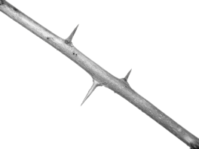

10a.   Buds appear to not have scales…. 11

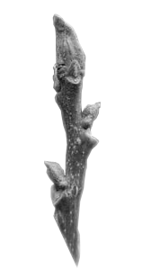

10b.   Buds with at least one defined scale……13

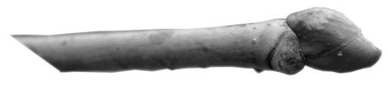

11a.   Leaf scars below bud; buds are yellowish in color…. ***Bitternut Hickory***

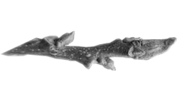

11b. Buds not yellowish in color….12

12a. Fat, stubby buds, grayish-brown with small hairs; leaf scars with no hairs; round fruit; brown inner bark ….***Black Walnut***

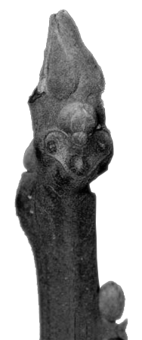

12b. End buds are paint brush shaped with dark brown color, circular and contain hairy flower buds; white raised leaf scars….***Pawpaw***

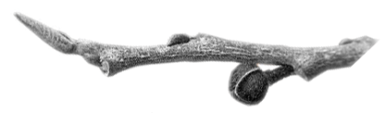  
  
13a. New growth twigs unmistakably red or pinkish-red; buds dark red, large, round, 2-3 scales; ……***American Basswood***

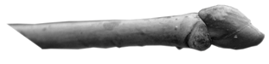

13b. Twigs do not appear as stated above.…14

14a. Buds and twigs green, broken twigs have a lemon odor; dead and old twigs turning orangish; inner bark orange….***Sassafras***

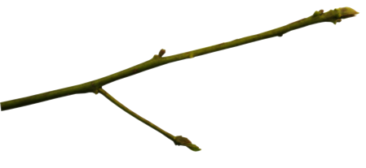

14b. Twigs of multiple colors, or with a duller green spread throughout; plants with 3 bundle scars or more……15

15a.   End buds gathered together in sets of 2-5; fruit, acorns…..16

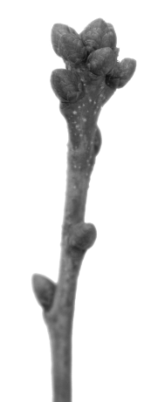

15b.   End buds false or contain one end bud…..20

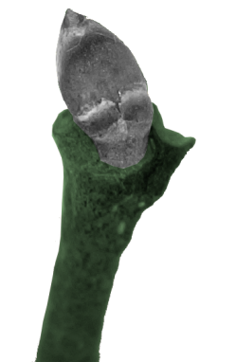  
16a.   Buds hairless, compact , round-blunt; twigs very long and narrow with a chalky white covering; bark white, chips away easily….***White Oak***



16b. Twigs normally without white and chalky coating; twigs and buds darker in pigment…..17

17a. Buds unmistakably reddish in color, do not contain hairs; vertical strips of smooth bark…..***Red Oak***

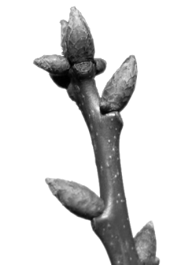

17b. Twigs and buds brown, not as above….18

18a. Bark of tree white and can be chipped away easily….***Chinkapin Oak***

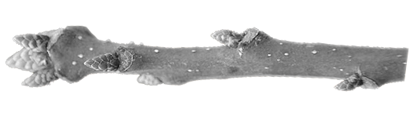

18b. Bark of tree darker in color and firm…..19

19a.   Branches growing outward; un-lobed leaves often remain attached late into fall; acorns small round, no stripes or faintly lined….***Shingle Oak***

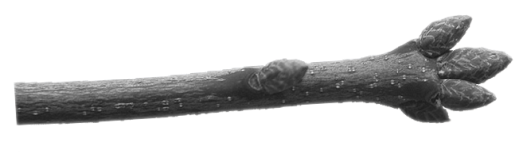

19b.   Lower branches often arch down; leaves are lobed; acorns small, round, with definite stripes….***Pin Oak***

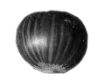  
20a.   Buds long, slender,pointed with many scales; buds have orangish scales; smooth gray bark; fruit a 3 sided nut in a spikey husk….***American Beech***

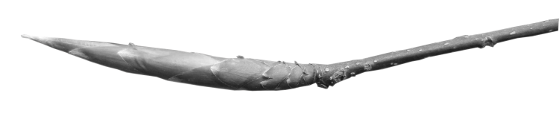

20b.   Buds shaped other than above….21

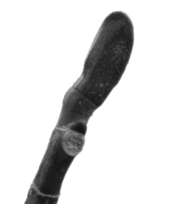

21a.   Two bud scales, come together like a duck’s bill; shallow furrowed bark; trunk grows tall and straight……***Tuliptree***

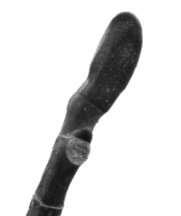

21b.   Buds shaped other than above…… 22

22a.   Buds unmistakably covered by a single scale, or seems to be single scaled….23

22b.   Buds many scaled…..24

23a.   Buds spiked, cone shaped; bark flakes off exposing smooth white trunk and branches…..***Sycamore***

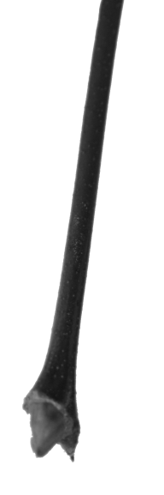

23b.   Buds clasp twig; twigs skinny, can be free of hair or slightly fuzzy, smooth, and shiny…….***Black Willow***

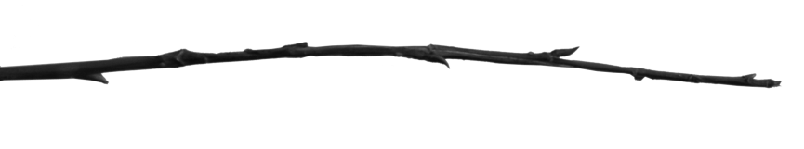

24a.   Twigs and buds similar shades of brown; twigs shiny and smooth but can be slightly hairy; buds always free of hair, shiny and smooth; bark has alternating layers of white and brown, very soft and cork like…..***American Elm***

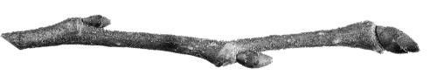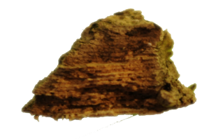

24b.   Buds and bark not as described above…… 25

25a.   End buds false… 26

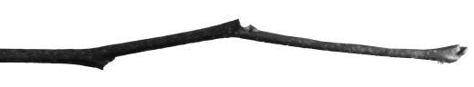

25b.   End buds true, or at least seem true….27

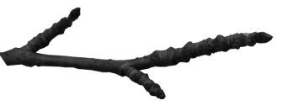

26a.   Light colored twigs with milky sap when split; buds burnt orange……***Red Mulberry***

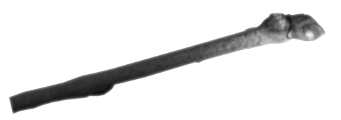

26b.   Twigs dark, white bumps present; buds dark, small, side buds in small stalks….***Redbud***

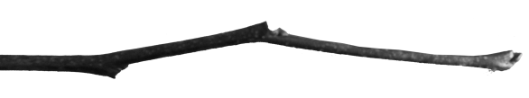

27a.   No apparent outward growth of twigs or branches; buds and twigs are glossy olive color; fruit, grape sized with spikes, green to brown in color….***Sweetgum***

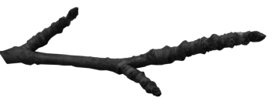

27b.   Twigs and branches with growth outward….28

28a.   Buds small, yellow and brown; twigs thin, with a strong smell of almonds when split; newer trees  contain horizontal white bumps on a rusty-brown bark, older trees with bumps splitting into black or burnt looking plates…… ***Black Cherry***

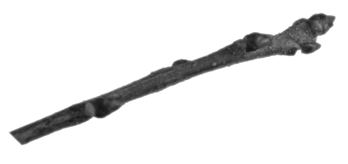

28b.   Twigs without any of the above characteristics….29

29a.   Trunk “muscular”; bark smooth, gray; buds angle, bud scales in definite rows……***Musclewood***

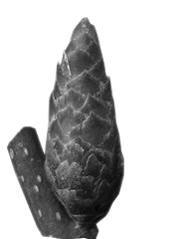

29b.   Trunk not as above; larger trees with long strips of “shaggy” bark….***Shagbark Hickory***

